Wireframe Documentation

Heart Disease Diagnostic Analysis

Revision Number: 1.1

Last date of revision: 13/09/2021

Shrey Shah

**Document Version Control**

|  |  |  |  |
| --- | --- | --- | --- |
| **Date Issued** | **Version** | **Description** | **Author** |
| 26th August, 2021 | 1.0 | Tableau Public Server Outputs | Shrey Shah |
|  |  |  |  |
|  |  |  |  |
|  |  |  |  |

**Contents**

Document Version Control2

1 Tableau Public Server Outputs4

1.1 Variation of ‘age’ with ‘chol’ (Cholesterol) variables4

1.2 Variation of ‘cp’ (Chest Pain Type) with ‘sex’ variables 5

1.3 Variation of ‘thal’ (Thalassemia type) with ‘sex’6

1.4 Variation of ‘thalach’ (Maximum heart rate) with ‘age’7

1.5 Variation of ‘chol’ (Cholesterol), ‘trestbps’ (Resting blood pressure) with ‘fbs’ (Fasting Blood Sugar) 8

1.6 Variation of ‘restecg’ (Resting electrocardiograph results) with ‘sex’9

1.7 Variation of ‘exang’ (Exercise induced angina) with ‘cp’ (Chest Pain type) 10

1.8 Variation of ‘slope’ (Slope of the peak exercise ST segment), ‘restecg’ (Resting Electrocardiograph results) and ‘oldpeak’ (ST depression induced by exercise relative to rest)11

1.9 Distribution of ‘ca’ (Number of major vessels)12

1.10 Variation of ‘num’ (Angiographic disease status) with ‘sex’13

**1 Tableau Public Server Outputs**

**1.1 Variation of ‘age’ with ‘chol’ (Cholesterol) variables**

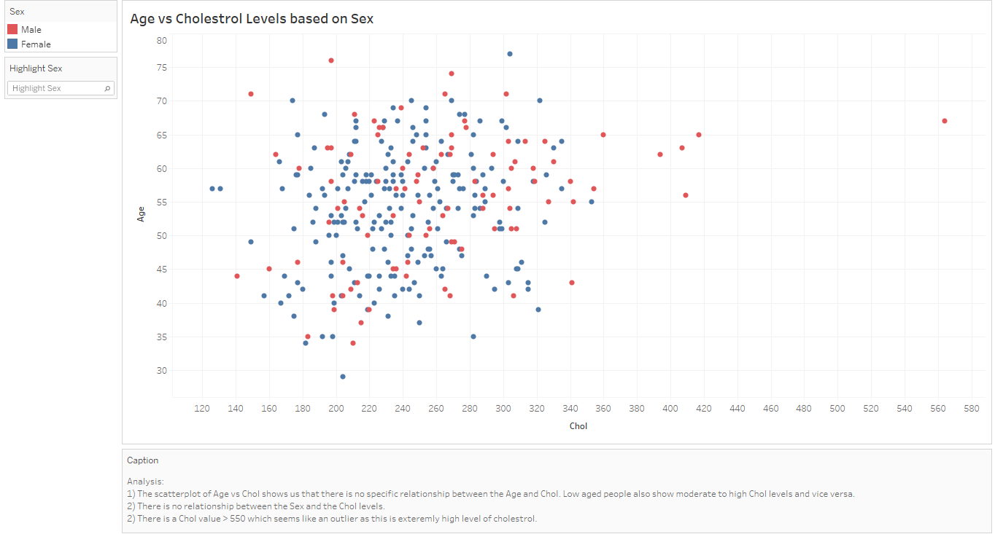

**Analysis:**

1) The scatterplot of Age vs Chol shows us that there is no specific relationship between the Age and Chol. Low aged people also show moderate to high Chol levels and vice versa.

2) There is no relationship between the Sex and the Chol levels.

3) There is a Chol value > 550 which seems like an outlier as this is extremely high level of cholesterol.

**1.2 Variation of ‘cp’ (Chest Pain Type) with ‘sex’ variables**

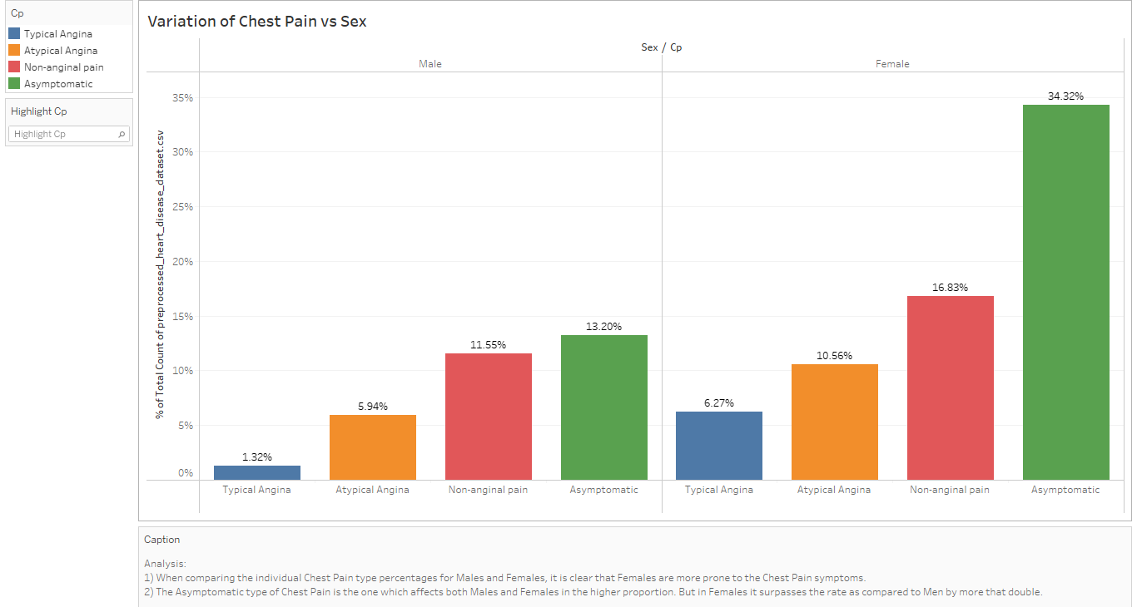

**Analysis:**

1) When comparing the individual Chest Pain type percentages for Males and Females, it is clear that Females are more prone to the Chest Pain symptoms.

2) The Asymptomatic type of Chest Pain is the one which affects both Males and Females in the higher proportion. But in Females it surpasses the rate as compared to Men by more that double.

**1.3 Variation of ‘thal’ (Thalassemia type) with ‘sex’**

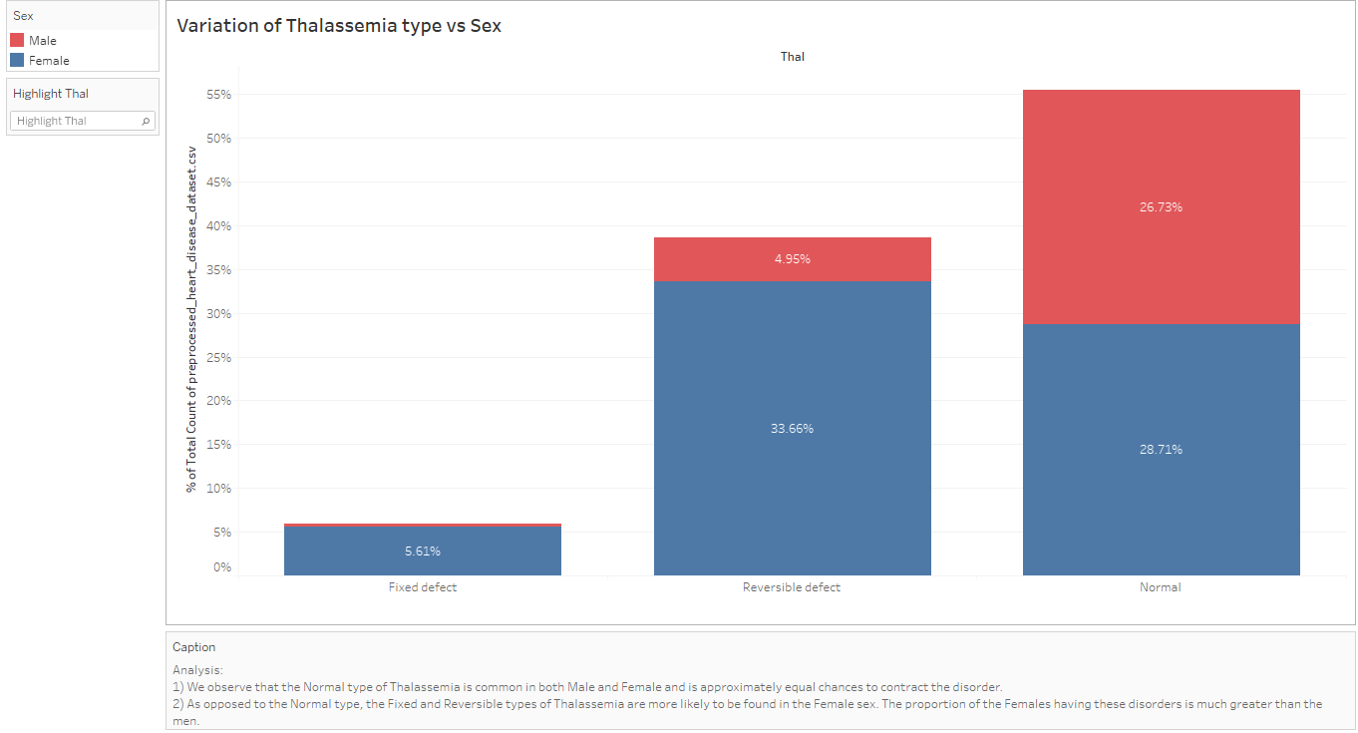

**Analysis:**

1) We observe that the Normal type of Thalassemia is common in both Male and Female and is approximately equal chances to contract the disorder.

2) As opposed to the Normal type, the Fixed and Reversible types of Thalassemia are more likely to be found in the Female sex. The proportion of the Females having these disorders is much greater than the men.

**1.4 Variation of ‘thalach’ (Maximum heart rate) with ‘age’**

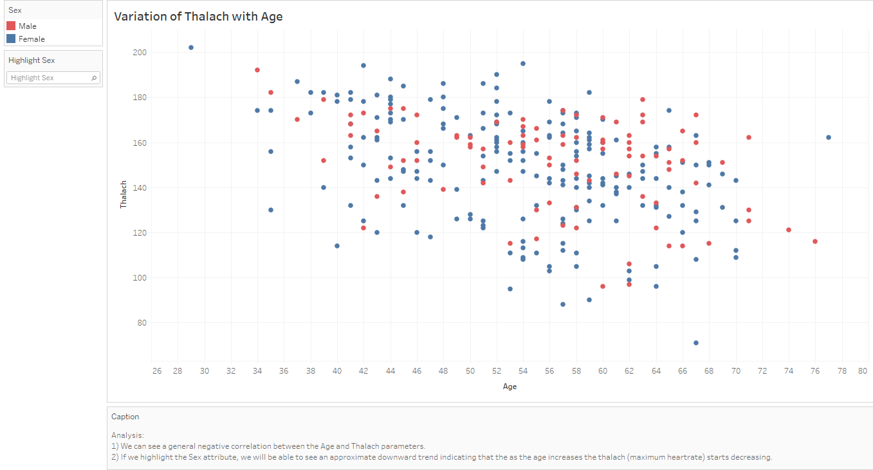

**Analysis:**

1) We can see a general negative correlation between the Age and Thalach parameters.

2) If we highlight the Sex attribute, we will be able to see an approximate downward trend indicating that the as the age increases the thalach (maximum heartrate) starts decreasing.

**1.5 Variation of ‘chol’ (Cholesterol), ‘trestbps’ (Resting blood pressure) with ‘fbs’ (Fasting Blood Sugar)**

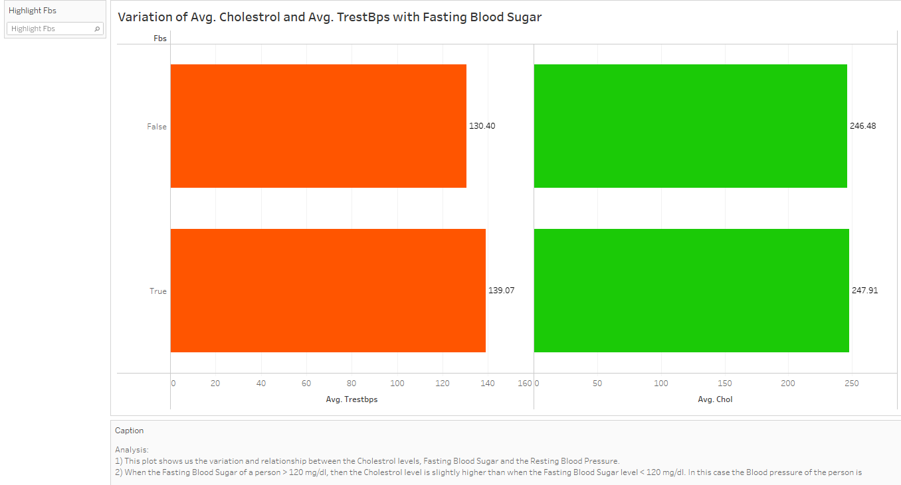

**Analysis:**

1) This plot shows us the variation and relationship between the Cholesterol levels, Fasting Blood Sugar and the Resting Blood Pressure.

2) When the Fasting Blood Sugar of a person > 120 mg/dl, then the Cholesterol level is slightly higher than when the Fasting Blood Sugar level < 120 mg/dl. In this case the Blood pressure of the person is higher than the Blood Pressure of the person whose Blood Sugar Level < 120 mg/dl.

3) This indicates that when the person fasts, the blood sugar level is less as the body uses the existing body sugar and the blood pressure is also low due to low activity.

**1.6 Variation of ‘restecg’ (Resting electrocardiograph results) with ‘sex’**

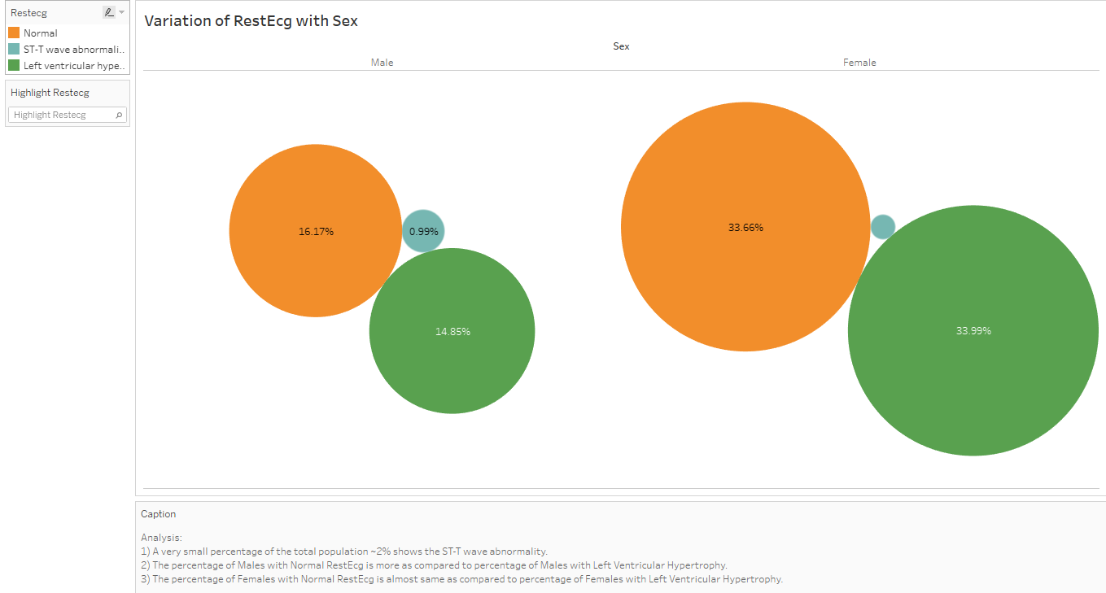

**Analysis:**

1) A very small percentage of the total population ~2% shows the ST-T wave abnormality.

2) The percentage of Males with Normal RestEcg is more as compared to percentage of Males with Left Ventricular Hypertrophy.

3) The percentage of Females with Normal RestEcg is almost same as compared to percentage of Females with Left Ventricular Hypertrophy.

**1.7 Variation of ‘exang’ (Exercise induced angina) with ‘cp’ (Chest Pain type)**

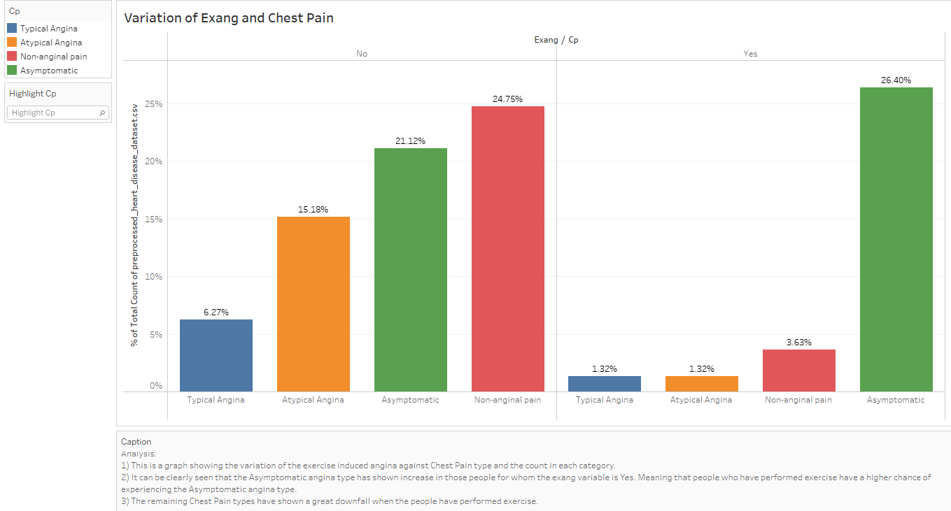

**Analysis:**

1) This is a graph showing the variation of the exercise induced angina against Chest Pain type and the count in each category.

2) It can be clearly seen that the Asymptomatic angina type has shown increase in those people for whom the exang variable is Yes. Meaning that people who have performed exercise have a higher chance of experiencing the Asymptomatic angina type.

3) The remaining Chest Pain types have shown a great downfall when the people have performed exercise.

**1.8 Variation of ‘slope’ (Slope of the peak exercise ST segment), ‘restecg’ (Resting Electrocardiograph results) and ‘oldpeak’ (ST depression induced by exercise relative to rest)**

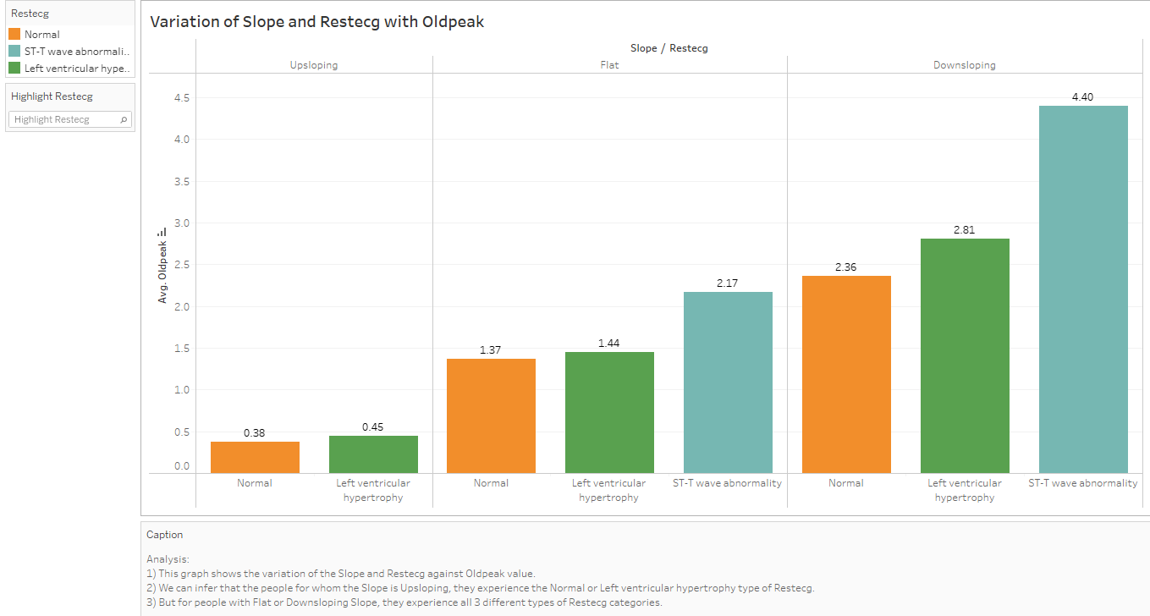

**Analysis:**

1) This graph shows the variation of the Slope and Restecg against Oldpeak value.

2) We can infer that the people for whom the Slope is Upsloping, they experience the Normal or Left ventricular hypertrophy type of Restecg.

3) But for people with Flat or Downsloping Slope, they experience all 3 different types of Restecg categories.

**1.9 Distribution of ‘ca’ (Number of major vessels)**

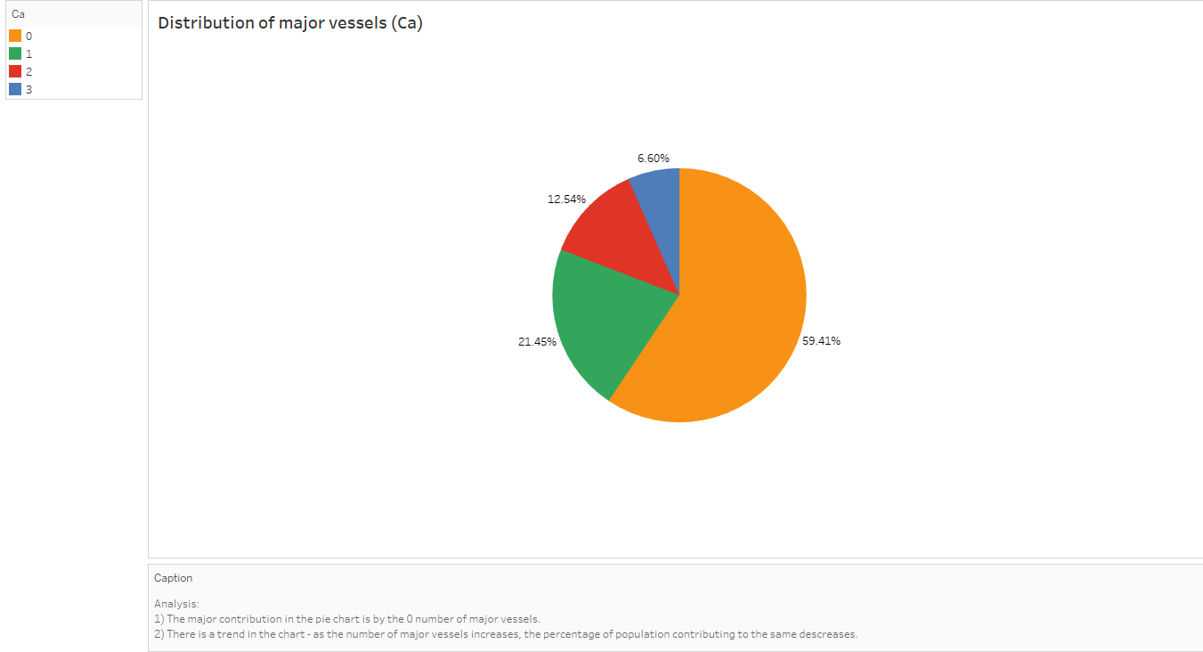

**Analysis:**

1) The major contribution in the pie chart is by the 0 number of major vessels.

2) There is a trend in the chart - as the number of major vessels increases, the percentage of population contributing to the same decreases.

**1.10 Variation of ‘num’ (Angiographic disease status) with ‘sex’**

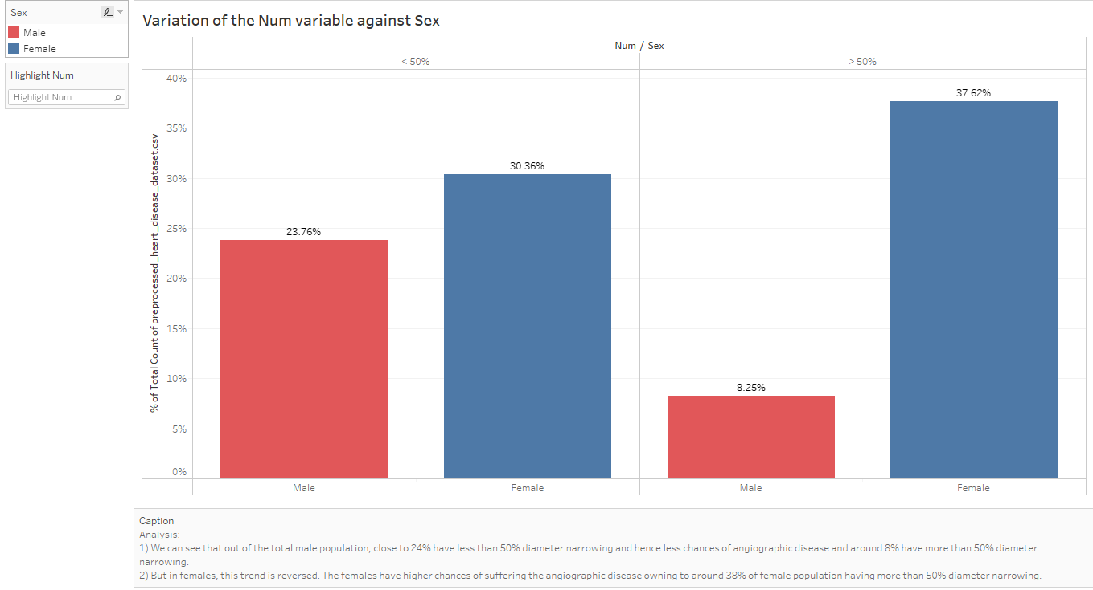

**Analysis:**

1) We can see that out of the total male population, close to 24% have less than 50% diameter narrowing and hence less chances of angiographic disease and around 8% have more than 50% diameter narrowing.

2) But in females, this trend is reversed. The females have higher chances of suffering the angiographic disease owning to around 38% of female population having more than 50% diameter narrowing.